Site Work Update – Week Ended November 13, 2009

Operable Unit 3
Creamer Environmental Inc, National Grid’s Remediation Contractor is continuing to mobilize to the site where the LIRR tracks were relocated. The mobilization includes bringing construction equipment, materials, and temporary facilities to the site. Creamer also continued site preparation activities including; soil and erosion controls, installed visual barrier along perimeter fencing and general housekeeping. Phase 1Sheet pile installation is progressing and will continue for the next few weeks. Creamer Environmental Inc is approximately 63% complete with the sheet pile installation of cells 1-7.
GEI, National Grid’s Remediation Oversight Consultant continues to perform CAMP (Community Air Monitoring Program), Noise and Vibration monitoring. CAMP will continue throughout the project while noise and vibration monitoring will cease after sheet pile installation is completed.

Two-Week Outlook
Creamer Environmental Inc. is expected to continue the mobilization of equipment, materials, and temporary facilities including mobilization and set-up of the Temporary Fabric Structure (TFS). Phase 1 sheet pile installation will continue throughout the next few weeks. Minor excavation and load out will commence to install wale support bracing in excavation cells 1-7.
General hours of operation will continue to be Monday through Friday, 7:00 AM to 3:30 PM. However, work hours will be extended when necessary to maintain schedule or to complete critical tasks. There will be no operations onsite Thanksgiving (November 26th and Friday November 27th ) with normal operations commencing Monday November 30th.
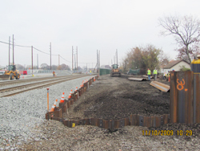
North south sheeting wall complete
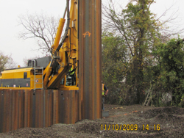
Installing 30' sheet

