Headline: Site Work Update – Week of November 2, 2009

North Clinton Avenue Restoration

During the week of November 2, contractors for National Grid will be completing the asphalt restoration of North Clinton Avenue. The work will require temporary closing of lanes while the asphalt re-paving takes place, but one lane will always remain opened, controlled by flag men. Please be careful driving through the area. The work is expected to take about one week.

Sheet Pile Installation in Brightwaters Yard Area
Creamer Environmental, National Grid's remediation contractor, will begin installing sheet pile later this week in the area of the Brightwaters Yard from which the Long Island Railroad tracks were relocated. The sheet piling is necessary to support the excavation work which is the major element of this remedial project. The excavation work in this area will continue into the mid-winter of 2010. In the Spring, after the tracks are relocated, sheet pile will be installed at the track’s current position and excavation will take place in that location. Vibration and noise monitoring programs with conservative action levels will be in place while the sheet pile is being installed.

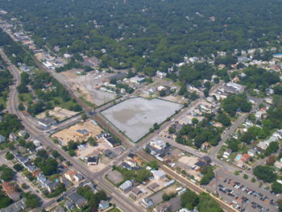
The Groundwater Treatment Facility is near completion and operational testing is beginning.

