Current Operable Unit 3 Remedial Progress for Phase II Week Ending 5/14/10
Creamer Environmental Inc., National Grid’s Remediation Contractor, has completed phase 2 sheet piling and all installation equipment has been de-mobilized from the site. Creamer also has started installing the internal bracing system (Walers) to the sheet pile line and will continue to do so for the next few weeks; in addition, the pre-excavation, transportation and disposal (T&D) of materials was completed this week. To date 32 trucks have transported approximately 926.11tons of soil to Bay Shore Soil Management (formerly ESMI of NJ) for thermal desorption.
GEI, National Grid’s Remediation Oversight Consultant, will continue to perform CAMP (Community Air Monitoring Program) and Noise and Vibration monitoring. CAMP and Noise and Vibration monitoring will continue throughout the project.

Two-Week Outlook
Creamer Environmental Inc. will continue to install the Waler system in each of the four cells for the next few weeks. Once each cell is completed with the Waler support system, Creamer will then excavate to design depth followed by backfilling the excavation.
General hours of operation will continue to be Monday through Friday, 7:00 AM to 3:30 PM. However, work hours will be extended when necessary to maintain schedule or to complete critical tasks.
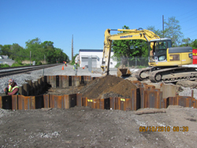
Excavating to install waler supports
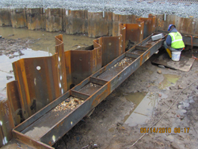
installing waler support in cell #11

